University Of Engineering and Technology, Lahore Computer Engineering Department

Course Name: PF | Course Code: CMPE-112L
Assignment Type: | Dated: 07june2026
Semester: 1st | Session: spring
Lab/Project/Assignment #: 15 | CLOs to be covered: CLO
Lab Title: | Teacher Name: Hafiz Muhammad Mubashar

Lab Evaluation:

CLO1 | Apply appropriate programming techniques to create executable programs to solve well defined problems
 | Level1 | Level2 | Level3 | Level4 | Level5 | Level6
(5)
Total |  |  |  |  |  | /5

Rubrics for Current Lab Evaluation

Scale | Marks | Level | Rubric
Excellent | 5 | L1 | Submitted all lab tasks, BONUS task, have good understanding.
Very Good | 4 | L2 | Submitted the lab tasks but have good understanding
Good | 3 | L3 | Submitted the lab tasks but have weak understanding.
Basic | 2 | L4 | Submitted the lab tasks but have no understanding.
Barely Acceptable | 1 | L5 | Submitted only one lab task.
Not Acceptable | 0 | L6 | Did not attempt

LAB No 15

Lab Goals/Objectives:
- To understand graphical user interfaces (GUI).
- To design user interface using Qt Designer.

Equipment Required:
- Computer/Laptop
- Qt Designer

Theory:

A Graphical User Interface (GUI) allows users to interact with software through windows, buttons, labels, text boxes, and other visual components instead of command-line instructions. Qt Designer is a drag-and-drop tool used to create GUI layouts quickly without manually writing interface code. GUI applications provide a more interactive and user-friendly experience compared to console-based program

Lab Work:

Task 1:

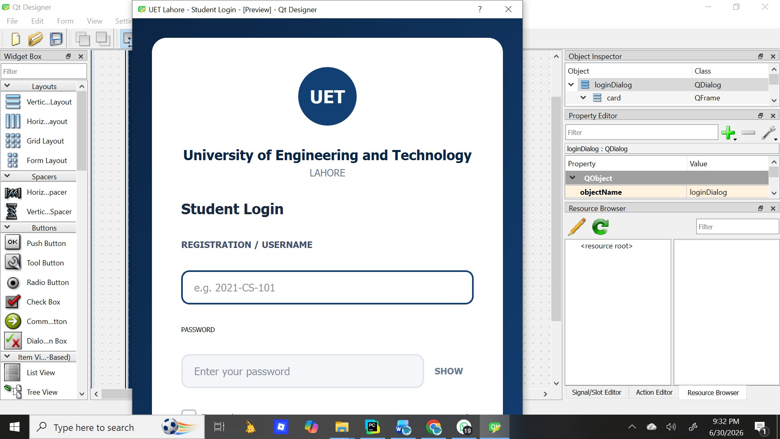
Result:

Create a login page

Conclusion
In this lab, we explored the basics of GUI development with Qt Designer. We learned how to design interactive windows by placing and configuring widgets like buttons, labels, and input fields without writing code manually. The drag-and-drop approach helped us understand layout management,

properties, and how to connect the visual design to Python logic. Overall, this lab gave us practical experience in building clean and functional user interfaces.

